Carpe Diem — Aldebaran

ABIGAIL LAM, Oregon State University  
KAYLA HUNTER, Oregon State University  
HANNAH MAUNG, Oregon State University  
BENJAMIN DAVIDSON, Oregon State University

We found that setting goals or creating habits is a large part of how college students and working professionals stay productive. For our initial designs and concepts for our application, we decided to focus on creating user interfaces that presented our ideas of the goal setting/habit tracker service. A big focus was showing the goal progression. That is what most people want to be able to see when they open their application. They get motivated to keep that progression streak. What works for one person, may not work for everyone. So one of the aspects we highlighted in one of the designs is having multiple ways to view the data of goal completion. It is important to make the user feel welcomed and supported, so a big focus of our designs was making them personable. We only covered the goal setting and habit tracking aspects of our project in these initial concepts, but it does a good job of presenting the design concepts of our whole application.

**KEYWORDS**

Habits; Goal; Progress; Productivity

# Introduction

The goal of this project is to create a compact, all-in-one application that provides users with the necessary tools to be organized and productive throughout their busy lives. This app is built with our team’s personal experience of being busy students, employees, athletes and much more, in addition to balancing a healthy personal life. Our application’s goal is to be all-inclusive in functionalities in order to help one be successful. These functionalities include the basic necessities such as calendars, to-do lists, notes, and reminders.

After conducting multiple rounds of research, one of our main findings is, users are looking for a way to track and look back on their progress. With that in mind, one of our main features to implement is a habit and goal tracker. Our habit and goal tracker will allow users to create customizable goals in addition to set custom reminders throughout the day. The user will then be sent reminders to log data for each goal. The application will display the user’s progress for each goal for the day in addition to correlating goal completion to each month or year.

This functionality allows users to not only use the application to organize their future, but reflect on their past. This allows users to better understand how their schedule impacts them and reflect on their goal progress. In addition, our application will be customizable to the user’s needs as no one person’s goals are the same. By doing so, we are aiming to help users stay organized and on top of their tasks along with progression of goals in everyday life.

# Concept 1

Our first concept’s first screen was created for the users to view all of their goals. The main feature of this screen is displaying the current date’s goals. The main image includes a progress circle of the percentages of goals completed on that particular date. Additionally, the individual goals are displayed with the percentage completed for the day. There is also an option to create a new goal. This button leads users to a page that allows them to add a new habit with an icon, a description of the habit and set reminders. This screen’s design focuses on using drop down bars to add information; however, there is an option to add custom information. The last screen displays goal progress. The top portion of the screen is a calendar which shows whether or not all goals were completed on each day. If all goals were completed on the particular day, the circle is filled in and if all goals were not completed, the circle is left empty. This gives a monthly summary of the user’s goal progress. The bottom portion of the screen is a bar graph showing the days of each month that all goals were completed. This gives a yearly summary of the user’s goal progress. This concept also features a bottom bar that allows users to navigate in between pages.

The first design decision for this concept was to include a yearly summary of progress. This summary showed the number of days per month all goals were completed. The title of the graph is simply the year. On the y-axis, we only included the 30 day mark and on the x-axis, we choose to include the first letter of each month. For example, “J” for January, “F” for February and so on. This was a design decision in order to save space but still display the months large enough for readability. Our original design implied that the months would go in order of the year. However, we understand that it is difficult to differentiate months since there are months with duplicate first initials (such as J for January, June, July), based on our feedback. Our solution may be to include the first three letters of the month, displayed vertically. For example, “Jan” for January, “Feb” for February and so on.

Our second design decision was to add multiple features that would allow users to view their goals and goal progress. On the first screen, we included a top section that displayed the users goal completion progress for the day in addition to arrows to scroll through the previous and next day. The first screen also contains a section that displays the progress of each individual goal for the day. On the second screen, we added a monthly calendar and yearly graph to track goal progress. Based on our feedback, this design decision may feel overloaded to some users. We understand that many users are using this application to help keep track of their busy schedules and having so much information on one screen may be overwhelming. A possible solution would be to separate these functionalities onto separate screens. For example, there could be a screen for the monthly progress and a different screen for the yearly progress. This would allow users to see more in-depth information for each functionality.

Our third design decision was on the view all goals screen, each goal included the name, icon, description and the progress for the day. We also included arrows for each goal however due to the scope of the assignment, the arrows do not include annotation lines to anything. Based on our feedback, this was a point of confusion because it seemed like clicking these would lead the user to the progress screen. However, these arrows were meant to lead to a new screen that would allow users to enter data for the specific goal on that particular day. When developing further into the concept, our solution is to continue adding screens that will clear up any confusion user’s may have on how to navigate the screens.

# Concept 2

The second concept takes a tiled visual approach that nests information on individual screens instead of surfacing everything all at once. Knowing that people view their goals page to either track their progress or create a new goal, these are the 2 prominent actions from the page (concept 2, screen 2). Adding a goal or viewing their progress is only 1 click away. While these concepts force the user to go through more screens, the flow is straightforward. There isn’t too much information on any one page.

This concept uses icons that represent a goal overlaid on a calendar grid view to easily see at a glance how they are tracking against their goal (concept 2, screen 4). From here the user can begin to understand patterns. For example, they tend to work out more in the beginning of the week versus on weekends. Another design decision was to use drop shadowing when indicating which goals you met that day (concept 2, screen 5). In order to easily say which goal you did that day e.g. exercising or drinking enough water, you only need to tap the goal icon. Since the screen serves dual purposes: accessing goal details vs. tracking goal progress, the “new” button becomes inactive in “Today” mode and the goal tiles have a stronger drop shadow. This visually tells the user which mode they are in so they don’t make any mistakes.

Several changes were made after receiving feedback on the initial designs. The majority of feedback was on the color scheme. The original coloring was not eye-catching enough. As a result, people did not want to interact with the concepts. There was positive feedback on the monthly view in the fifth screen. The only negative feedback was around the stars and what they mean. Initially, we used 2 different colors to indicate whether the goal was met for the week. That was confusing and would require a legend to understand what each color means. The design was modified as a result to only have one color and instead use fill to indicate whether or not the goal was met (concept 2, screen 4).

# Concept 3

The third concept focuses on tracking goal/habit progress. The main feature of this concept is for users to be able to easily and effectively track the progress of each goal that they wrote down in the app. Being able to track goal progress is extremely important because it allows us to see how far we have progressed or what things we need to improve on. Tracking helps us stay focused, motivated, and positive. Our group came up with three different screens for this concept that takes a different approach to tracking goal progress.

The first screen of this concept shows a calendar view of all habits in a month, as well as a yearly summary. The screen has a calendar where users can navigate from month to month and view their monthly progress. Days that are colored in means that the goal was completed for that day. Underneath the calendar is a bar graph that displays how many days of the month goals were accomplished. The graph also has navigation arrows so users can view their progress by month.

The second screen of this concept shows a calendar view of a specific habit in a month. It includes a grid that represents a calendar, each individual box representing one day of the month. The calendar has a corresponding icon of that goal on each day that the goal was completed. For example, bicycle icons are used as the symbol to track exercise. There is a star icon next to each week. A blue, colored star means that the goal for that week was accomplished, but an unfilled star means that it was not. This is a great feature that allows the user to easily view their goal progress and identify their problem areas. Above the calendar is a statement that explains their exact goal target and why they want to achieve that goal. This is another great feature because it motivates the user and gives them a reminder as to why they chose that goal in the first place.

The third screen of this concept shows a graph view of each habit in a day. It has a bar graph that tracks the goal progress of each goal that the user had per day. Each bar represents a different goal and there is a key at the bottom to make sure users understand. The screen displays the correct date and day and also allows the user to navigate days so they can see their goal progress on a different day. The screen has an “overall day rating” which explains the average percentage of all the goals. The progress is measured from a 1-5 scale which users can personally pick. There is also a notes section at the bottom so users can write down any comments they have, such as a reason why they didn’t do so well that day. This screen wanted the app to be very personable and create a welcoming place for users to jot down their thoughts and feelings.

After reading class feedback, there were many changes that were made to each concept and design. The main things include changing the color scheme to make the app brighter and navigation between screens. The third screen of this concept specifically added more colors and changed the goal tracking page to be per goal per page, instead of displaying all goals per page. This allows the page to add more features and describe the goal in more detail than the previous design. The second screen also changed their background color to a bright blue, compared to a gray.

# Concept Assessment

## Advantages

One advantage of Concept #1 is how it gives the user multiple visualizations to track their habits/goals progress and is extremely detailed. For example, the “view goals” page has a pie graph that states overall goal completion and individually breaks down each goal component. In addition, the “progress” page has a calendar view of all the habits as well as a yearly summary. It has a physical calendar view and a bar graph. This is great because users can view both their daily and monthly progress, as well as view their progress in different ways. Some people like to visualize their progress differently than others, so this gives the best of both worlds for our app users.

One advantage of Concept #2 is it’s tiled vision approach. The app looks very minimalistic and clean. Because of this approach, the app eases the navigation process, enhances brand value, delivers a polished message, and requires less maintenance for the development team. In addition, it creates a great foundation for the app and allows our team to easily build on it. Having an app that is easily navigable is extremely important and definitely sets apps apart from others.

One advantage of Concept #3 is how personable it is. When creating a goal, the app allows the user to write their description and target, while the other concepts have limited characters or a drop down menu. This concept acts like a journal too, allowing the user to write down exactly what they want to accomplish and why. This brings a great motivation aspect as well because the user is able to constantly read the “why” to each habit/goal they created.

## Disadvantages

One disadvantage of Concept #1 is that the user is limited to very basic goals and that is it. They are only able to create daily goals, as there is no option for weekly or monthly goals. The user would be able to split up a weekly goal into 7 chunks, but that would require them to put an equivalent amount of effort into the goal each day. Rather than being able to finish a weekly goal in a lesser amount of time, such as 4 days throughout the week. When it comes to the details of the goal, the user is limited to a title and description. There is no option for setting a category, color coding, or difficulty ranking.

One disadvantage of Concept #2 is that there is no overall view of the user’s goal progression. The user is able to click on one of their goals, then view the progression. However, there is not a way to see an overview of today’s progression of every goal. It makes the user have to put in a lot of effort to check their goal progress. With only a couple goals, it is not a big issue. Although, when you start keeping track of more and more goals that means you have to continually click on each goal to check the progression.

One disadvantage of Concept #3 is that there is only one way of viewing the past goal completion. That is a 7 day(week) bar chart view. It is not necessarily a problem. However, a lot of users are going to want to see a little bit of a bigger picture of their success. A monthly or yearly progress report is going to be beneficial to more people.

# 

# 

# 

# 

# Appendix

## Concept 1

Before

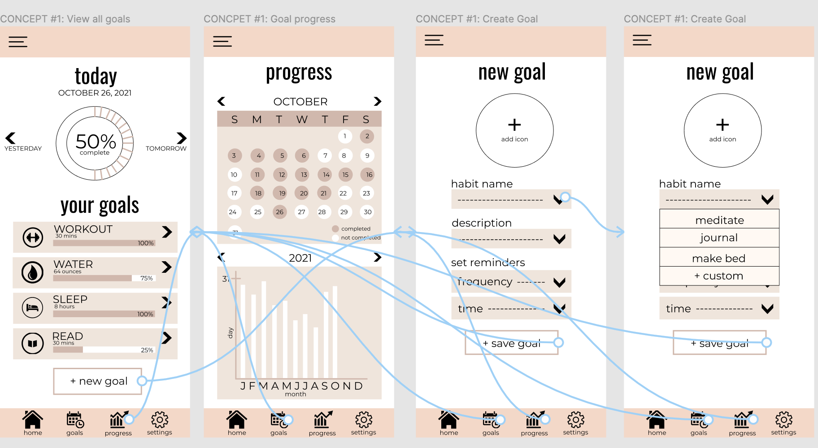

After

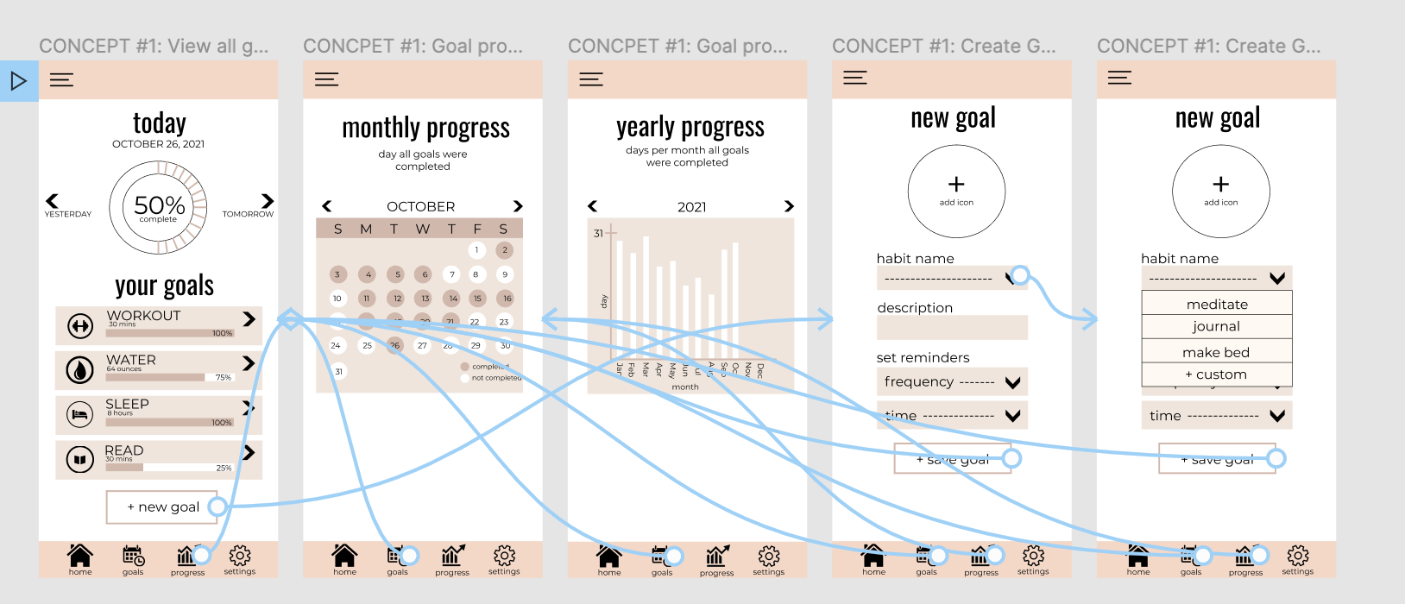

## 

## 

## Concept 2

Before

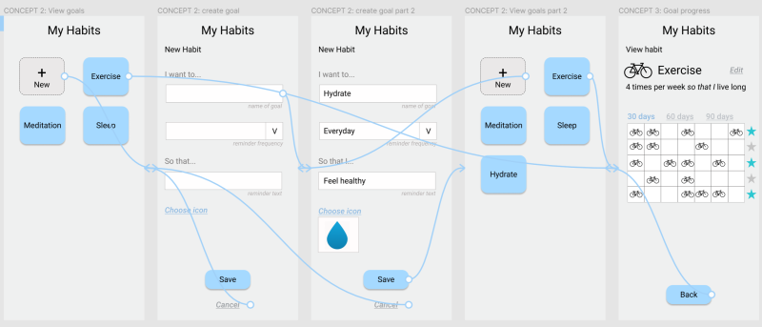

After

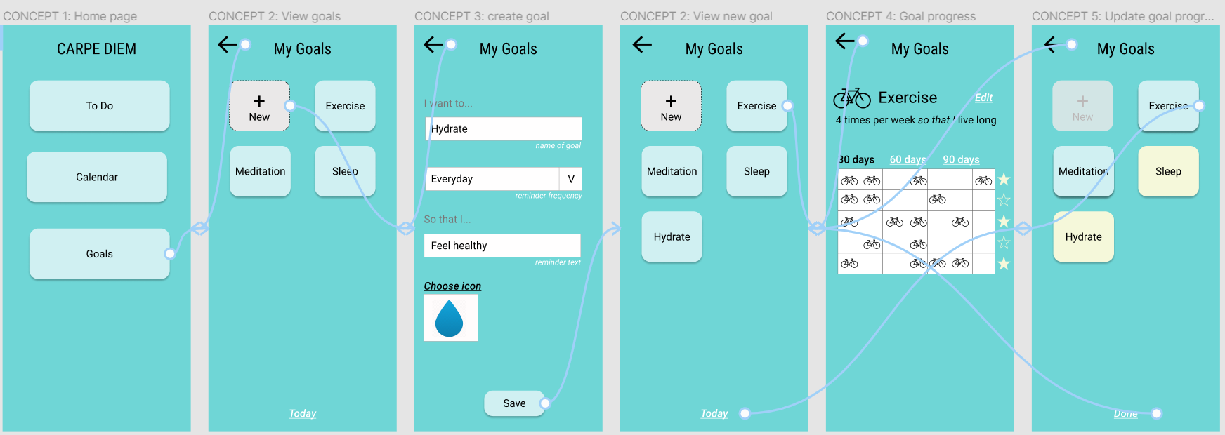

## 

## 

## 

## 

## 

## Concept 3

Before:

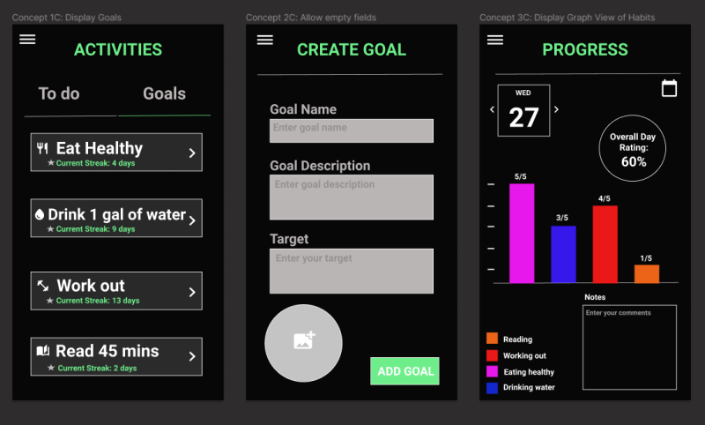

After:

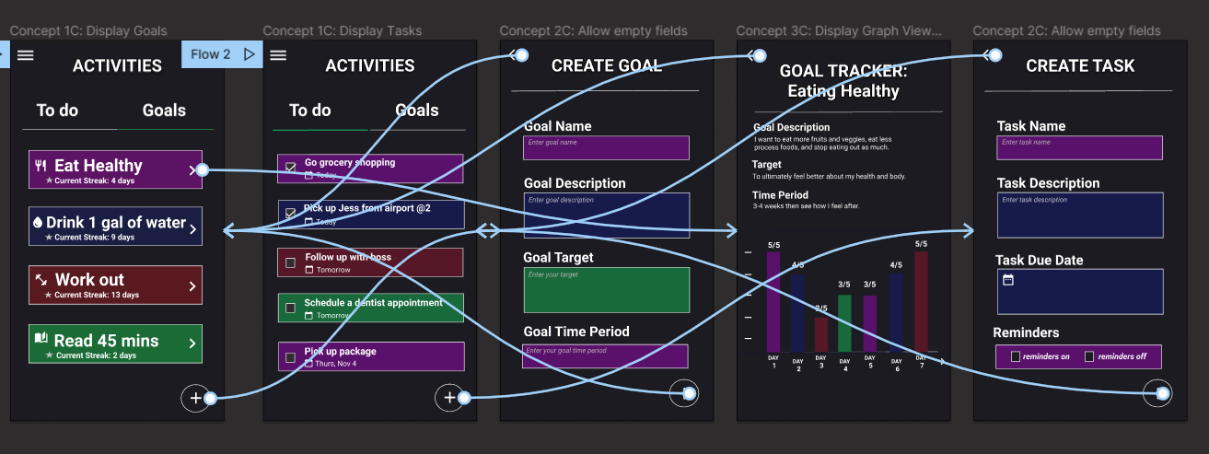

## Reviews

<https://docs.google.com/document/d/1dq-nlAyWCkMLjzfXbchdi4yX7CN0YAaEjmRLvkXKR_M/edit?usp=sharing>